Erectile and Ejaculation Dysfunction

In
Chronic Prostatitis

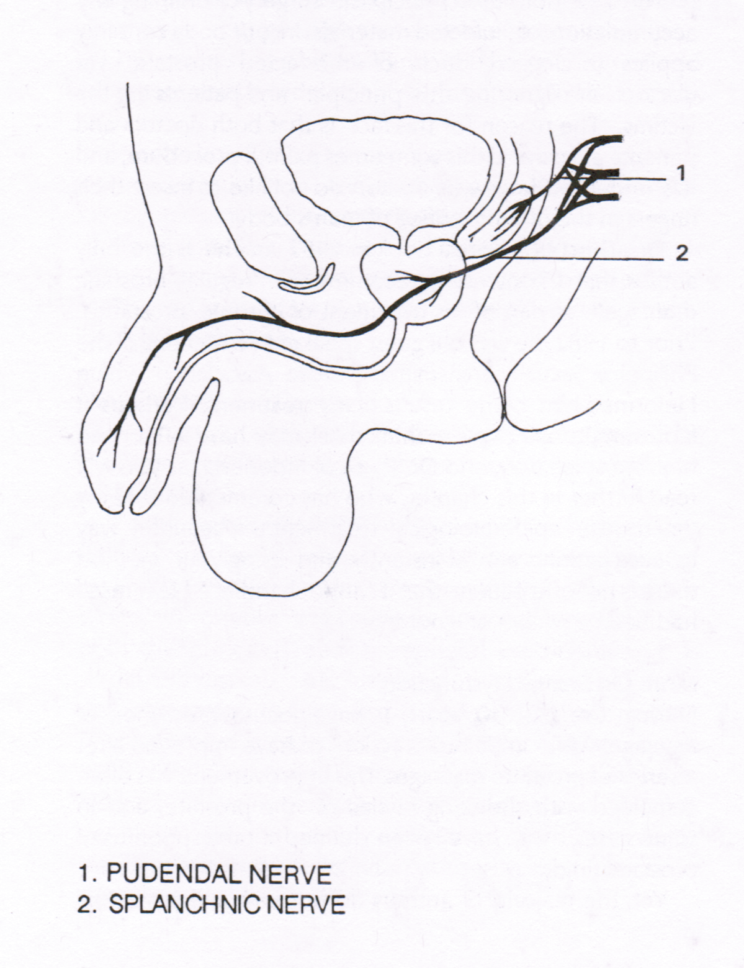

About 25% 0f our patients with Chronic Prostatitis have erectile and or ejaculatory disorders. Most of them improve with the treatment. This improvement coincided with shrinkage in size of the prostate and in many cases evacuation of prostatic fluid to as much as a tablespoon.

Illustration above shows the two nerve tracts for ejaculation (1) and erection (2). From the spinal column the nerve tract travels toward the front Portions of the Punendal nerve end up to the seminal vesicle, while the Splanchnic nerve travels through the prostate and into the cavernous smooth muscles of the penile shaft.

Erection is the final common pathway of the integrative synchronized action of psychological, neuronal, hormonal, vascular, and cavernous smooth muscle systems.
Ejaculation is a function of the pudendal nerve. The end effect of the nerve stimuli is rhythmic contraction of the perineum muscles.
An infection of the prostate and the seminal vesicle may interrupt the flow of nerve signals and may cause disturbances in erection and ejaculation thus affecting the neuronal and, vascular and cavernous smooth muscle system.

Physiology:
Erection occurs with increase blood flow to the spongy muscles of the penis and closure of the arteriovenous shunt. This is similar to a gardener turning on the faucet (nerve impulse) and garden hose being filled up with water and pressure produces a rigid hose (blood entrapment).
The innervations of this mechanism come across parasympathetic nerve fibers that travel in the pelvic splanchnic nerve and enter the prostatic plexus. The nerve tract then continuous and ends in the penile erectile tissue within the penile shaft.

Emission is the filing of the bulbar urethra by the sequential contraction of the prostate, seminal vesicle and vas deference. The smooth muscles of these organs are innervated by the adrenergic sympathetic fibers.
Ejaculation is primarily mediated by means of the pudendal nerve. Distention of the bulbar urethra by seminal emission is sensed by the afferent fibers of the pudendal nerve and combined with cortical stimuli produces a motor respond in the pudendal nerve. Rhythmic contraction of by the perineal muscles surrounding the cavernous tissue forcefully propels the ejaculate from the urethra.

